Earth Overshoot Day 2018 is August 1
Partners around the world to join #MoveTheDate Live Stream
On August 1, humanity will have used nature's resource budget for the entire year, according to Global Footprint Network, an international research organization. This date is called Earth Overshoot Day—the date when humanity's annual demand on nature exceeds what Earth's ecosystems can renew in that year.
In other words, humanity is currently using nature 1.7 times faster than our planet’s ecosystems can regenerate. This is akin to using 1.7 Earths.
Global Footprint Network calculates Earth Overshoot Day every year using Ecological Footprint accounting, which adds up all of people's different demands on nature including demand for food, timber, and fibers (cotton); absorption of carbon emissions from burning fossil fuels; and buildings, roads and other infrastructure. August 1 is the earliest Earth Overshoot Day since the world went into ecological overshoot in the 1970s.
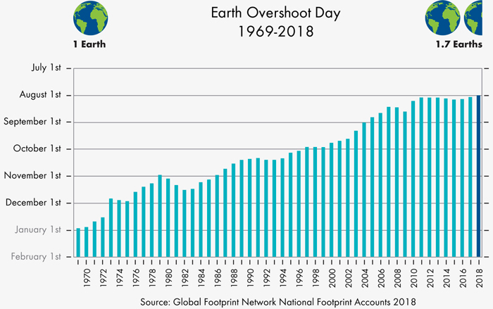
The costs of this ecological overspending include deforestation; collapsing fisheries; fresh-water scarcity; soil erosion; biodiversity loss; and the buildup of carbon dioxide in the atmosphere, leading to climate change and more severe droughts, wildfires, and hurricanes. These threats can produce desperation and force many people to migrate to cities or other countries.
Global Footprint Network and its partners will mark Earth Overshoot Day 2018 with several activities around the world, including:
- In New York, a short video in Times Square from July 20 to August 3 featuring stunning footage by award-winning cinematographer Louie Schwartzberg.
- From Hong Kong, Paris, and Oakland, Global Footprint Network and Schneider Electric will host a webinar at 8 a.m. PDT / 3 p.m. UTC on Tuesday, July 24, about Earth Overshoot Day and energy solutions. Registration details will be available soon at www.overshootday.org.
- In Berlin, Germanwatch and Inkota will hold an Overshoot Day press conference at 9 a.m. CET on August 1.
- In Rio de Janeiro, Brazil, the Museu do Amanhã (Museum of Tomorrow) will show a special screening of "Under the Ox Paw," a documentary film about the cattle invasion in the Amazon, on August 1.

#MoveTheDate Live Stream
Global Footprint Network will feature these events and more with interviews from around the world through a live broadcast on Facebook and YouTube at 11 p.m. July 31 PDT / 6 a.m. Aug. 1 UTC and 9 a.m. August 1 PDT / 4 p.m. UTC. To watch, visit www.facebook.com/GlobalFootprintNetwork.
The show will include interviews with Christiana Figueres, the former climate chief of the UN; Erik Solheim, executive director of the UN Environment Programme; Nicolas Hulot, the French minister of ecological transition; Terry A'Hearn, Chief Executive Officer of the Scottish Environment Protection Agency; Esther Finidori, Manager of Environmental Performance and CO2 Strategy, Schneider Electric; and cinematographer Louie Schwartzberg. The show also will feature partners from WWF China, France, Japan, and Russia; ZERO, an environmental partner in Portugal; and from the U.S., the American Sustainable Business Council, Center for Biological Diversity, Cloud Institute for Sustainability Education, Earth Day Network, Powerhouse, and Turning Green.
"As we mark Earth Overshoot Day, today may seem no different from yesterday—you still have the same food in your refrigerator," said Global Footprint Network CEO Mathis Wackernagel. "But fires are raging in the Western United States. On the other side of the world, residents in Cape Town have had to slash water consumption in half since 2015. These are consequences of busting the ecological budget of our one and only planet."
“Our economies are running a Ponzi scheme with our planet. We are using the Earth's future resources to operate in the present and digging ourselves deeper into ecological debt,” Wackernagel continued. "It's time to end this ecological Ponzi scheme and leverage our creativity and ingenuity to create a prosperous future free of fossil fuels and planetary destruction."
Global Footprint Network is inviting individuals to participate in Earth Overshoot Day by determining their own Personal Overshoot Day and Ecological Footprint at www.footprintcalculator.org and taking a "Step to #MoveTheDate" at www.overshootday.org/steps-to-movethedate/.

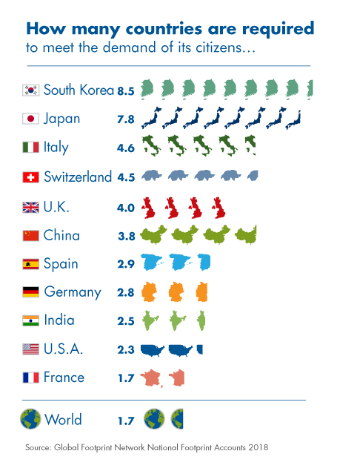
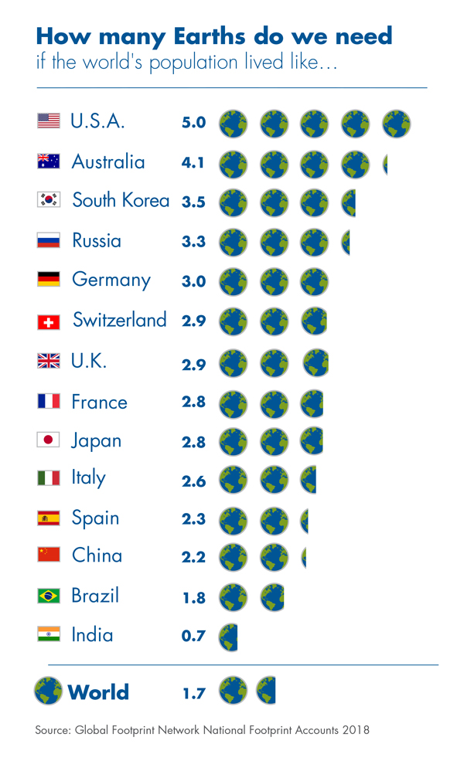
##

Useful Links:
Full press release: www.overshootday.org/newsroom/press-release-july-2018-english/ (to be live on July 23)

Media Backgrounder: www.overshootday.org/newsroom/media-backgrounder/
More on Earth Overshoot Day: www.overshootday.org
Live Stream (Aug. 1): www.facebook.com/GlobalFootprintNetwork
Footprint Calculator: www.footprintcalculator.org

Country Footprints: http://data.footprintnetwork.org

Social media: #MoveTheDate
Overshoot Day Videos: Coming soon!
About Global Footprint Network
Global Footprint Network is changing how the world manages its natural resources and responds to climate change, through
- METRICS that are simple, meaningful, and scalable;
- ACTIONABLE INSIGHTS about natural resource consumption and capacity; and
- TOOLS and analysis to guide informed decisions.
www.footprintnetwork.org
Media Contacts
Amanda Diep  Communications Manager  Global Footprint Network  +1-510-839-8879x309  amanda.diep@footprintnetwork.org | Laetitia Mailhes  Communications & Outreach  Global Footprint Network  +1-415-794-2884  laetitia.mailhes@footprintnetwork.org

